Use larger objects to show tens (spaghetti or pencils) and smaller numbers to show ones (peas or beads) Eg **24** is 2 strands of spaghetti and 4 beads

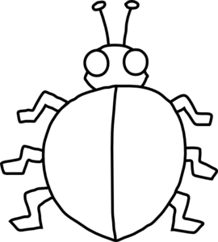

**Tens Ones**

|  |
| --- |
| These are the 2-digit numbers I made. |