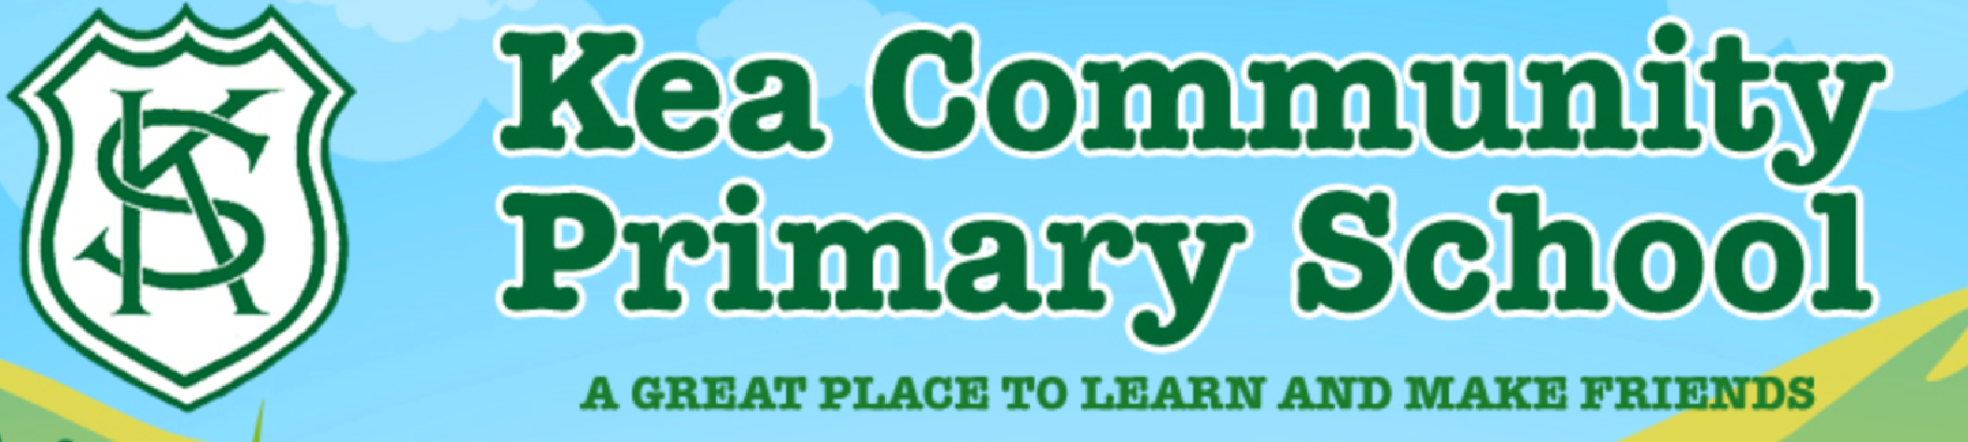
Maths and Literacy Learning Plan
Date: 22nd February 2021 | Class: Foundation
Dear Parents and Carers,
We do hope that you have had a good half term. We are looking forward to sharing the planned learning with you and the children, both at home and in school over the next few weeks.
You can find ideas for afternoon learning at the bottom of this weekly learning plan. Any additional resources are on the weekly home learning page on the website. Please remember that you don’t have to do it all. Some reading/phonics, a little bit of writing and some maths each day is fine.
This week, we would like to see the following activities on Tapestry. You may post additional work for us to see too if you wish:
- Your designed pair of pants.
- A piece of maths work that you feel proud of.
Please contact us should you need any help at any time.
Catherine and Lisa
Literacy
Reading | RWI  Watch the daily RWI phonics videos for today. To find these videos please follow this link:  https://www.youtube.com/channel/UCo7fbLgY2oA_cFCIg9GdxtQ?mc_cid=71ef745098&mc_eid=c9705b8c67  Reading  Read your reading book daily, either borrowed from the box in reception at school or online. Also practise some of your red words.
Handwriting | This week, choose a couple of red words from the red word list at the front of your reading record to practise writing. You can also find the red words on the general resources page on the website.
Literacy Tasks | Monday  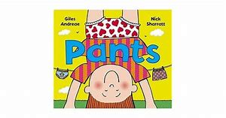  Pants!  Watch the video lesson on ‘Pants’. What pants would a superhero, pirate, witch, princess, explorer or clown wear? Design your own pair of pants for someone else to wear. It could be one of the characters from the list above, or you can choose your own. You can do this task however you wish, using colouring, paint or collage. There is a blank pants template under the daily resources, or you can draw one of your own.  Tuesday  Watch the video lesson for Tuesday. Describe a pair of pants. You can either use a pair in the book ‘Pants’ or use the pair that you designed yesterday. You could label the pants with a few words or write some sentences to describe the pants. Remember sentences have a capital letter, finger space and full stop. We would love to see your finished pants design and writing on Tapestry.  Wednesday  Watch the video literacy lesson for the day. You will listen to the story ‘The Queen’s Knickers’, hear the national anthem and learn a little about the Queen. Next, we would like you to find the answers to the following questions by researching all about our Queen:  Who is the Queen? What does she look like? How old is she? How many birthdays does she have?! Where does she live? Can you find her on coins? What does she sometimes wear on her head?  Thursday  Watch today’s Literacy Video Lesson. This lesson is all about sticks and having stick adventures. Think about all the things you could use your stick for. Go outside and find some good sticks. Make up a game with your stick. What could it be used for? There is a link to ‘Stickman’ by Julia Donaldson on the webpage should you wish to enjoy that (it’s about half an hour long).  Friday  Watch today’s Literacy Video Lesson. Today, you will continue to think about your special stick from yesterday. You can write a label for your stick or write a sentence or two to describe your stick. You may even like to draw a picture of you having an adventure with your stick.

Maths
This week, you can choose a few of the subtraction activities from below. Most are working towards the Early Learning Goal objective in subtraction. Some challenge you eyond the ELG. You don’t have to do them all but can pick and choose: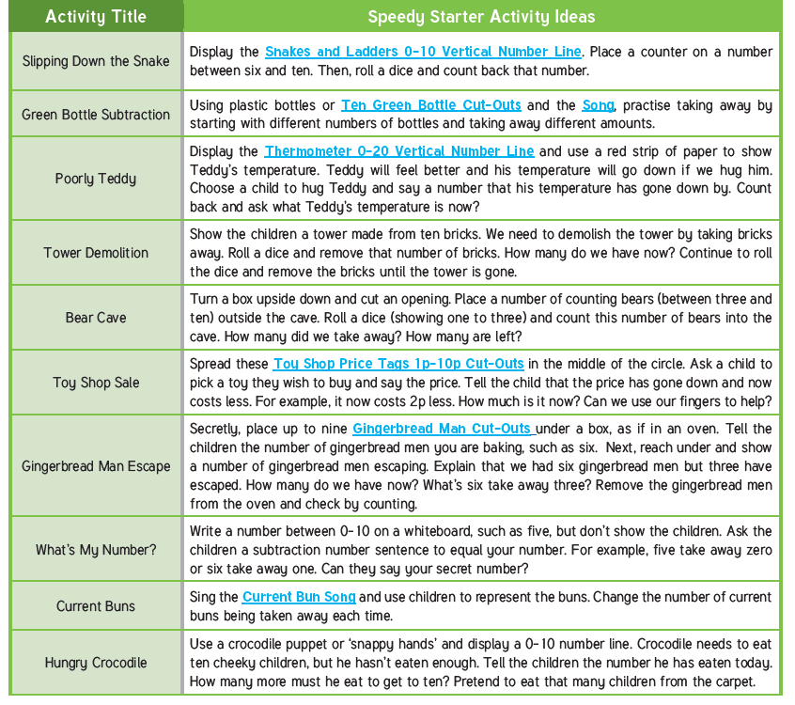
Learning Tasks | Monday  Watch today’s video maths lesson about ordering numbers. Today, you will order numbers to 10 and will correct mistakes in the ordering. To extend your learning, you could place numbers on a blank numberline and guess hidden amounts. You could also order numbers to 20.  Tuesday  Watch today’s video maths lesson about the composition of 9 and 10. You will be looking at different ways to show 9 and 10, through pictures. Your task is to show 9 and 10 in pictures.  Wednesday  Watch today’s White Rose video lesson on counting backwards from 10. After, you can sing songs that count backwards. For example, Ten in the Bed or Alice The Camel. Perhaps you can act this out with 10 teddies. Use the language of take away when you are doing this activity. An extension would be to write a couple of subtraction number sentences (ie: 3-1=2).  Thursday  Watch today’s White Rose video lesson. After, with a friend, take handfuls of objects. Who has the most, who has fewer. Use a number line to find your numbers. You could also do this activity by filling up containers with objects (remember the work we did on capacity). To extend this, can you work out how many more or less than someone else you had?  Friday  Watch today’s White Rose video lesson. After, roll a 1-6 dice. Then use dominoes to find out if your domino has fewer, more or the same number of spots as the dice. You can print the dominoes from the attached file on the website.

