
KEA COMMUNITY PRIMARY SCHOOL
A great place to learn and make friends.
Year 4 homework – Summer Term

Level 1 Homework (must be completed and handed in by the due date)
Times Table Rockstars- 15 minutes per week (ideally 3 minutes a day, 5x a week). A garage task has been set on TTRS.

Spelling Shed- 15 minutes per week (ideally 3 minutes a day, 5x a week).

Work on the spelling assignment you have been set (containing statutory spellings). When you reach ‘Royal Bee’, a Mastery Zone Button will appear. Children should then click and play on this it will automatically determine their spelling strengths and areas for improvement. Also, more games will appear for you to play!

Reading - 5x a week (ideally for 5-10 minutes each time). In year 4 this can be reading quietly rather than aloud and listened to, however a combination of both is welcomed.
Please ensure that all reads are entered into reading records as these will be counted on a Friday.
For Level 1 homework, the week runs from a Friday to Friday.

Level 2 Homework (we would love you to have a go at completing this and share it with your class teacher). For the rest of half term.
When practising your spellings you may wish to use the spelling menu on our class homework page. I look forward to seeing some of your word lists.
Spelling practise  Have a go at some spelling and grammar activities via this link;  https://www.topmarks.co.uk/english-games/7-11-years/spelling-and-grammar | Time table practise  Have a go at some multiplication  and division games via this link:  Times Tables Games
Geography based ideas  1.River Diary Entry – Write a diary entry from the perspective of a river, describing its journey from source to mouth.  2.Acrostic Poem – Create an acrostic poem using the word RIVERS.  3.Famous Rivers of the World – Choose one famous river (e.g. the Nile, Amazon, or Thames) and create a fact file or poster.  4.River Model – Build a 3D model of a river showing features like source, waterfall, meander, and mouth.  5.River Pollution Study – Research how rivers can get polluted and how we can help keep them clean. |  | 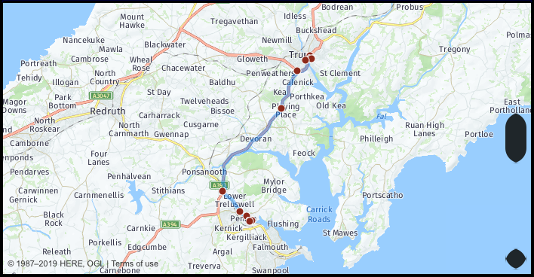
Learn the following KIRFS (suggest 2 minutes a day 5x a week) There will
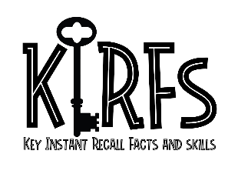
be a KIRFS quiz set at the end of each half term.

- I can identify and label the main stages of the water cycle, including evaporation, condensation, precipitation, and collection.​
- I can recognise and describe key features of a river such as the source, mouth, meanders, tributaries, and floodplains.​
- I can describe the human and physical geography of UK cities, counties, and regions,
including how rivers influence the landscape and settlements.​
- I can use four-figure grid references accurately to find locations and features on a map.

- I can suggest why being part of a community is important, such as for support, shared values,
and celebrating together making links to school. ​
- I can make links between beliefs and special events, understanding how religious or
cultural beliefs shape celebrations.​
- I can identify festivals that are unique to Cornwall, such as Obby Oss Day in Padstow and
Golowan Festival in Penzance.

Level 3 Homework (we would love you to have a go at these ongoing projects, artwork or research tasks and bring them in when ready)
Piece 1 – River Fact File or Mini-Book - Research and present information about a famous river (e.g. River Thames, Nile, Amazon).
Sections to include:
Where is it?
Key features (length, countries it flows through, animals that live near it).
Why is it important to people?
Piece 2 – Human Impact Poster or Presentation
Objective: Explore how humans affect rivers.
Ideas to cover:
- Pollution, dams, flooding, conservation.
- What can people do to help protect rivers?

Healthy Body, Healthy Mind ‘Homework’
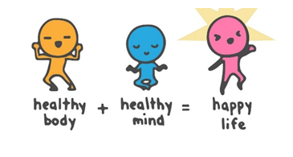
If you have any queries, or have a piece of heathy body, Healthy Mind.
Ask me via dhead@kea.cornwall.sch.uk
